**Birla Institute of Technology and Science,Pilani**

**CS F212 Database Systems**

**Lab No # 9 B**

*************************************************************************************

1 Working with MongoDB

After successfully completing the installation of MongoDB.

Let’s learn how to work on this non-relational Database system.

5.1 **To know the existing databases:**

Using ‘show dbs;’. Initially, it shows the list of default databases as shown below.



5.2 **Creating a new Database:**

For creating a new database:

Syntax->> use database_name

Example->> use xyzdb

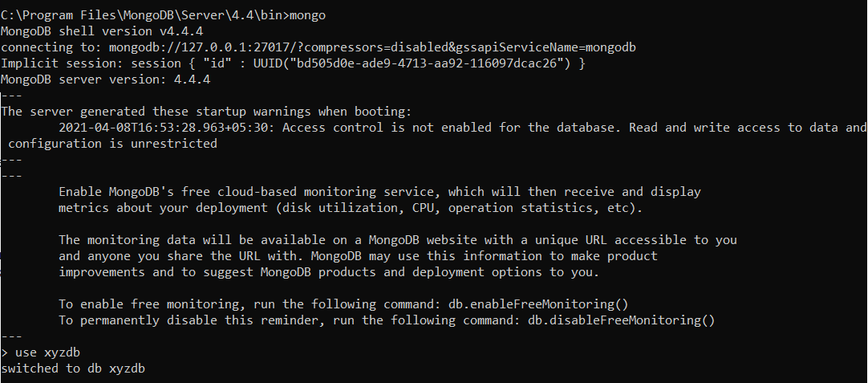

Databases are not shown until we add some collections to the database.

Here, after switching the database to xyzdb, xyzdb is still not available in the list of databases.

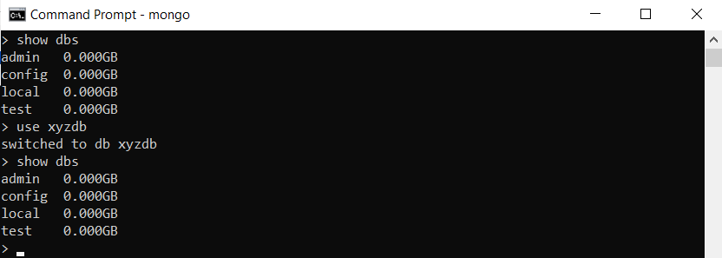

5.3 **Creating Collections**

In MongoDB we have various databases and these databases have various collections.

A collection is a group of documents.

There are 2 ways we can create collections in databases.

1. Using the createCollection() method:

Syntax: db.createCollection(“collection_name”)

Example: db.createCollection(“employee”)

This will create a collection as “employee”

Now inserting documents into the collection “employee”.

Syntax: db.collection_name.insert({"field_name":"field_value"})

Example: db.employee.insert({"empname":"emma"})

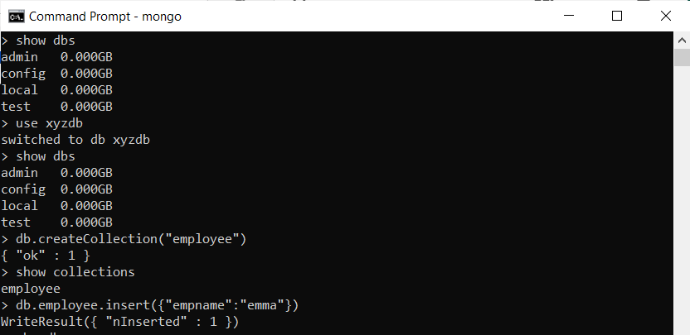

After inserting documents into the collection, the name of the database inside which the collection exists, can be seen in the list of databases.

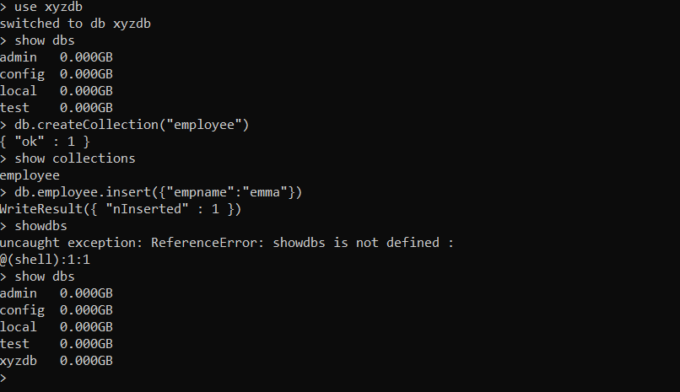

1. Another way to create a collection is the direct way.

Syntax ->> db.collection_name.insert({“Field_name”:”Field_value”})

Example ->> db.department.insert({"deptname":"operations"})

This will insert the field name and its respective value in a collection with ‘department’ as name.

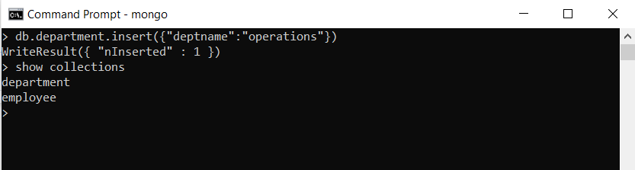

NOTE: The database will be available only after we add some collections to it.

To look for the collections in the database use ‘show collections’.

Here the database is ‘xyzdb’ and inside the database we have a 2 collection: employee and department.

5.4 **Retrieve a document from Collection**

To retrieve the documents inside a collection use the method find().

Syntax: db.collection_name.find()

This gives the documents inside a particular collection. MongoDB automatically adds a unique id field to the document.

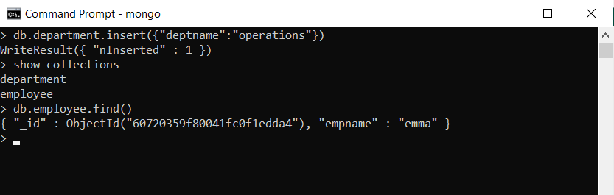

5.5 **Drop a collection from Database**

To delete a collection from the database

Use the drop() command.

Syntax: db.collection_name.drop()

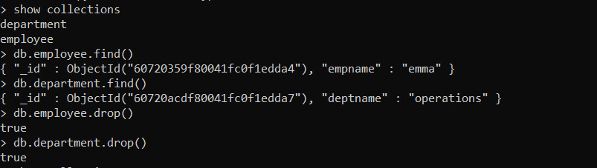

5.6 **Drop a Database**

Use command dropDatabase().

This will delete the database as well as the collections inside the database.

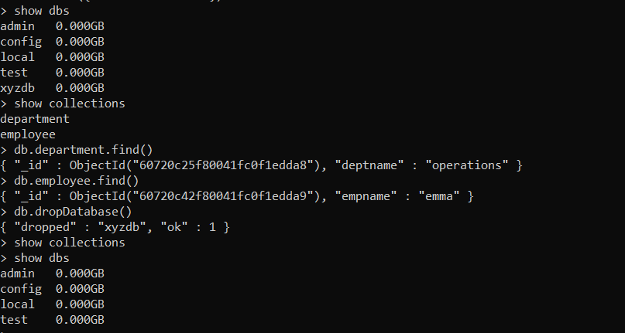

5.2 CRUD Operations in MongoDB

CRUD operations are to Create, Read, Update, and Delete Documents.

5.2.1 **Create Operations**

Create or insert operations add new documents to a collection. If the collection does not currently exist, insert operations will create the collection.

MongoDB provides the following methods to insert documents into a collection:

* Using **insert()** method.

db.collection_name.insert({field_name: field_value})

Here creating and inserting 2 documents into the collection ‘employee’ inside the database xyzdb.

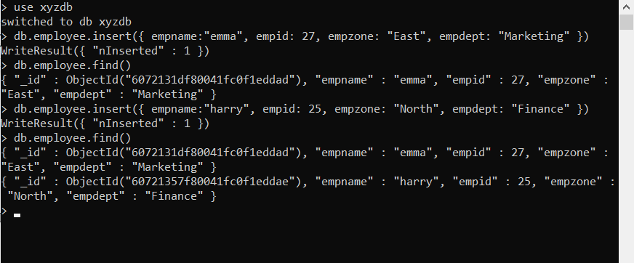

* Using [db.collection.insertOne()](https://docs.mongodb.com/manual/reference/method/db.collection.insertOne/#mongodb-method-db.collection.insertOne)*,* inserts a single document into a collection.

Run the following to insert a single document into the inventory collection :

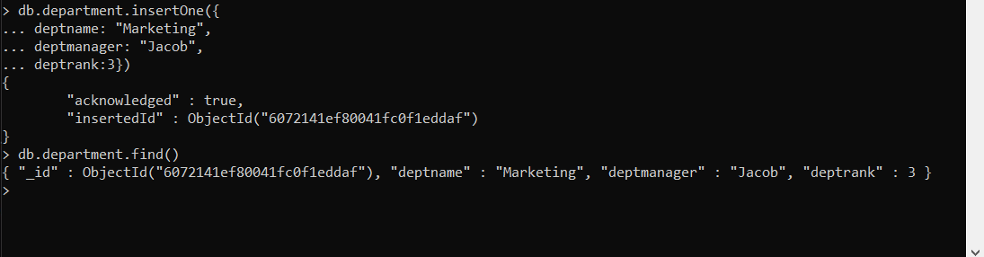

To retrieve the document that you just inserted, query the collection with:

**db.department.find()**

* [db.collection.insertMany()](https://docs.mongodb.com/manual/reference/method/db.collection.insertMany/#mongodb-method-db.collection.insertMany) can insert *multiple* documents into a collection. Pass an array of documents to the method.

Run the following to insert multiple document into the inventory collection :

Here, inserting several entries together inside the collection ‘client’ using insertMany() command.

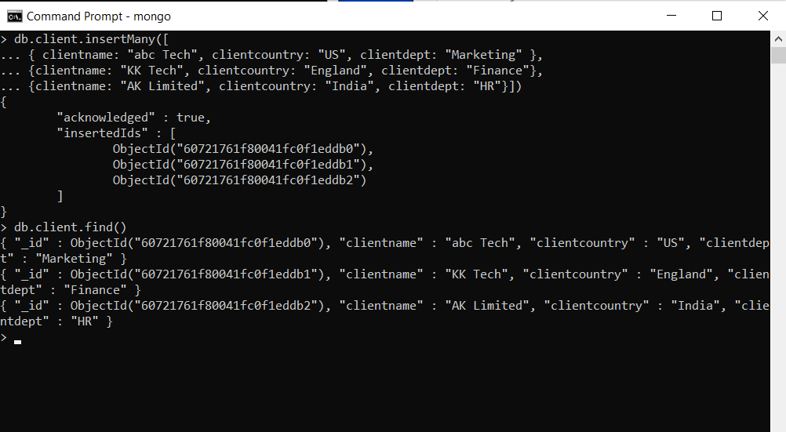

To Read operations retrieve documents from a collection; i.e. query a collection for documents.

MongoDB provides the following methods to read documents from a collection:

* [db.collection.find()](https://docs.mongodb.com/manual/reference/method/db.collection.find/#mongodb-method-db.collection.find)

5.2.3 **Update Operations**

Update operations modify existing documents in a collection. MongoDB provides the following methods to update documents of a collection:

* Using the **update()** method

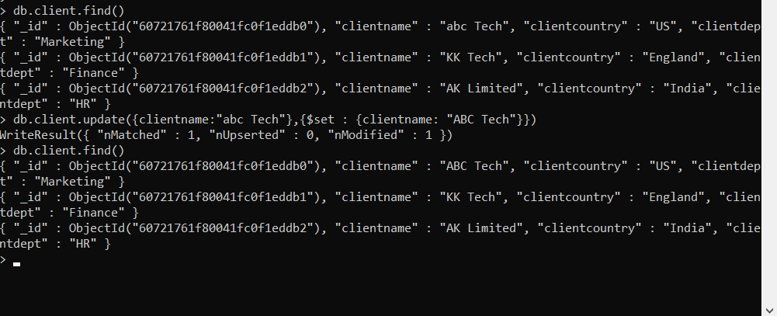

* [db.collection.updateOne()](https://docs.mongodb.com/manual/reference/method/db.collection.updateOne/#mongodb-method-db.collection.updateOne)

The following example uses the [db.collection.updateOne()](https://docs.mongodb.com/manual/reference/method/db.collection.updateOne/#mongodb-method-db.collection.updateOne) method on the inventory collection to update the *client name where value is “abc Tech” to “ABC Tech”.*

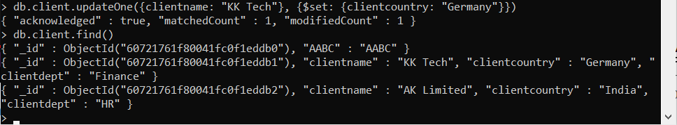

Here the update operation uses the ‘$set’ operator to update the value of the client name.

* [db.collection.updateMany()](https://docs.mongodb.com/manual/reference/method/db.collection.updateMany/#mongodb-method-db.collection.updateMany)

This method is used to update the selected values at once. Here, the selected value gets changed at all places.

If we had 2 instances for client name: “KK Tech”, both of their departments would be updated to “Accounting”.

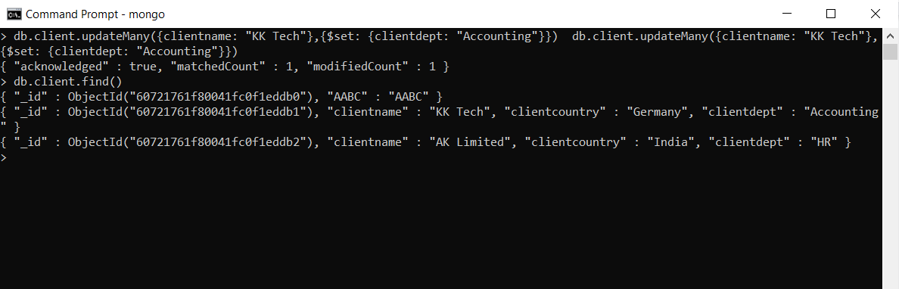

Here the update operation uses the ‘$set’ operator to update the value of the client department to “Accounting”.

* [db.collection.replaceOne()](https://docs.mongodb.com/manual/reference/method/db.collection.replaceOne/#mongodb-method-db.collection.replaceOne)

This method replaces a selected field name to another name.

Here, in the client collection, the client name was replaced as ‘AABC’ from ‘ABC’.

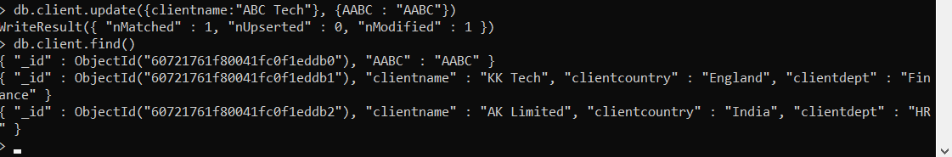

5.2.3 **Delete Operations**

Delete operations remove documents from a collection. MongoDB provides the following methods to delete documents of a collection.

* Remove documents from the collection.

Use the remove() method to delete a particular collection with a specific field value.

Here, a document is deleted from the employee collection with empid= 25.

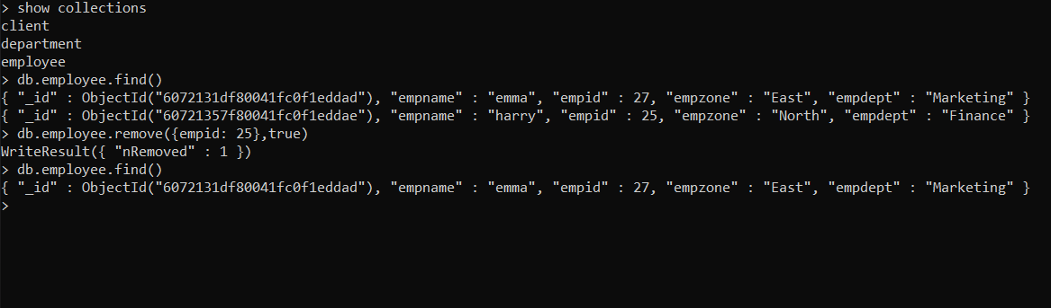

* [**db.collection.deleteOne()**](https://docs.mongodb.com/manual/reference/method/db.collection.deleteOne/#mongodb-method-db.collection.deleteOne)

Here, only one specific document is deleted at a time. In the below example, the document is deleted using its unique id value.

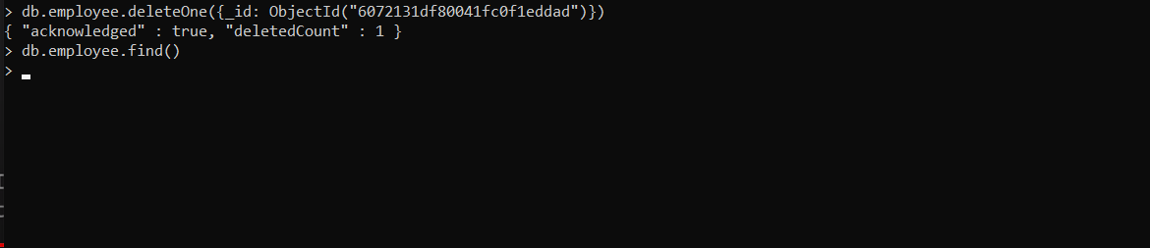

## [**db.collection.deleteMany()**](https://docs.mongodb.com/manual/reference/method/db.collection.deleteMany/#mongodb-method-db.collection.deleteMany)

## To Delete All Documents specified.

Here, all the documents in the employee collection with empid=25 were deleted all at once.

Note the count of deleted documents = 3.

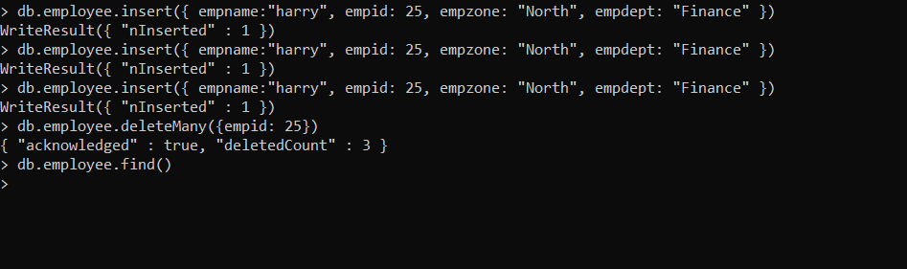

***********************************END***************************************